ShopHub

___________________________________________

Website Documentation

Product Testing

___________________________________________

Student Name: Nischal Aryal

Student ID: 77261069

Module Name: Production Project

# Testing

## Integration testing

* + Scenario: 1
  + Scenario: 2
  + Scenario: 3
  + Scenario: 4
  + Scenario: 5
  + Scenario: 6

## Test Case

## Integration testing:

### Scenario 1

**Task:** Create a new account

**Persona:** Niyanta Chettri

**User Group:** Non- registered customer

#### Scenario

So now here Niyanta is non registered customer. She found our website very useful and now she wants to become user of our website.

### Steps:

* Niyanta opens website of **ShopHub** in her browser,
* She clicks on My Account,
* She clicks on Register icon,
* She enter her information in registration form
* Validation of any error is available in form.
* She also has to agree on terms and conditions before registration
* Fulfilling all details requirement she is registered.
* Niyanta is verified as new customer of ShopHub website

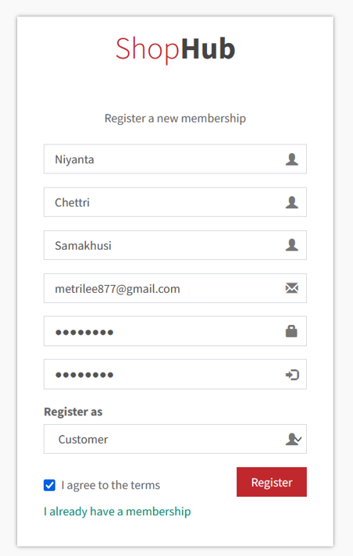

## Scenario 2

**Task:** Login to a registered account

**Persona:** Niyanta chettri

**User Group:** Registered customer

#### Scenario

Nayanta verified registered customer and wants to login to ShopHub website

### Steps:

* Nayanta opens ShopHub site in her browser
* Nayanta clicks on **Login**
* Nayanta enters her details in the Login form
* Instant validation for any mistakes in the Login form is available
* Nayanta clicks **Submit** button
* Nayanta is now logged in

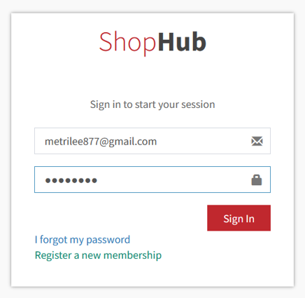

### Scenario 3

**Task:** Add Products to **Cart**

**Persona:** Non Users/Users

**User Group:** Registered or non-registered customer

#### Scenario

Registered or non-registered customer wants to add product to the whistle list

### Steps:

* User add to favorite by clicking product and add to Cart button
* User see favorite product in the index page

Non registered user

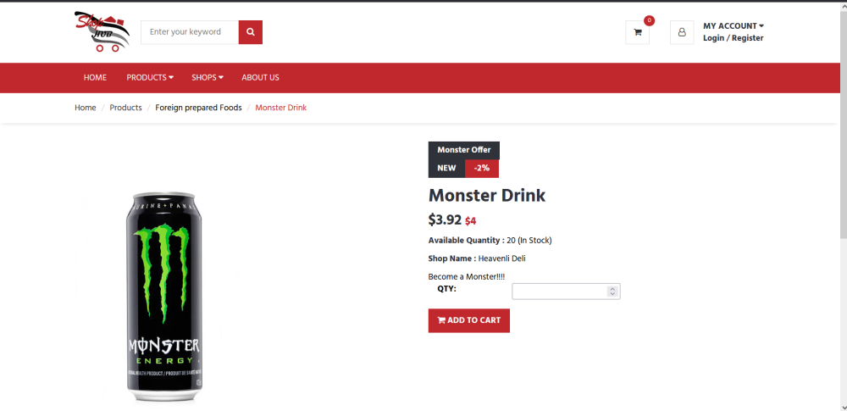

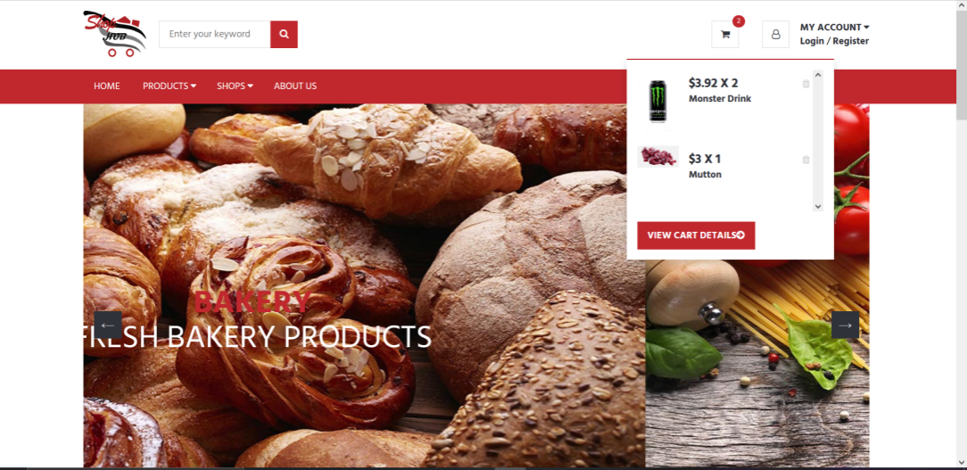

Registered customer

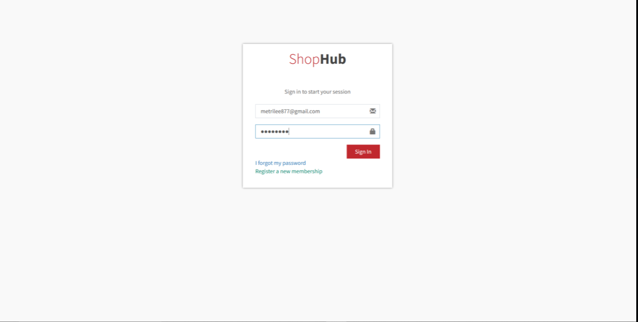

Login customer can view their product in cart

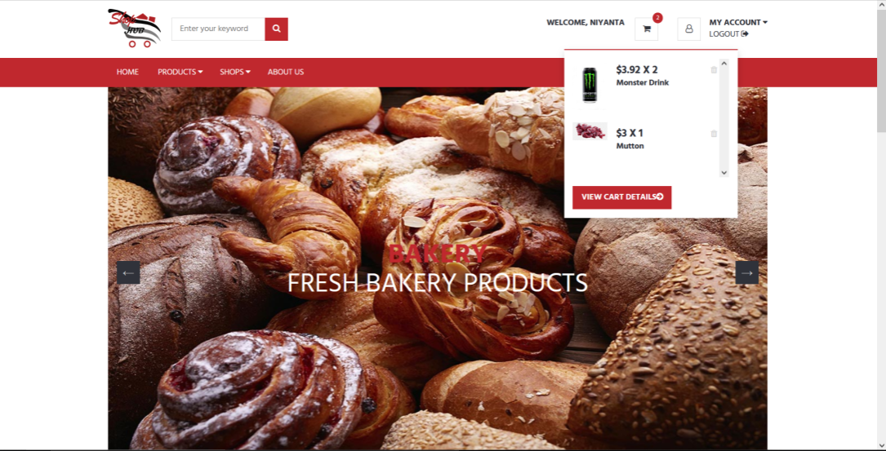

Cart Detail

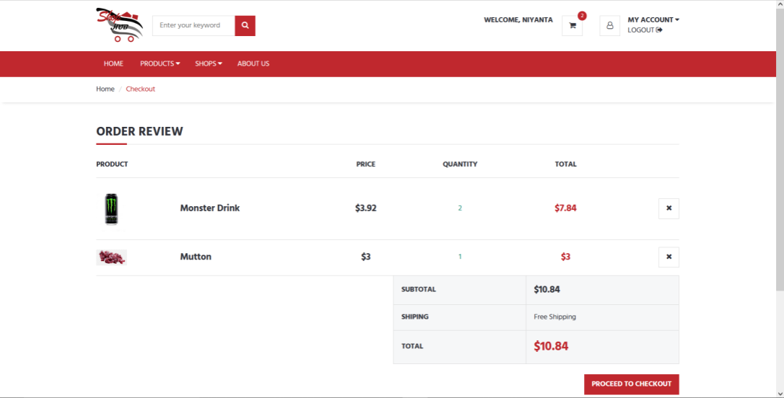

## Scenario 5

**Task:** Check-outfrom Cart

**Persona:** Niyanta Chettri

**User Group:** Registered Customer

#### Scenario

### Niyanta is a registered fresh user of ShopHub. She wishes to check-out from the cart so that she can purchase goods from the site.

### Steps:

* Niyanta opens ShopHub site in his browser
* Niyanta selects the desired product of choice
* Niyanta adds product to cart by clicking the add to cart button
* Niyanta is redirected to the **login** page
* Niyanta enters his details in the Logins
* Niyanta clicks **login** button
* Niyanta is now a registered user
* Niyanta will have product list in cart
* Niyanta can now select the day and time and click finish button
* Niyanta sees invoice and clicks paypal button to proceed to payment
* Niyanta logins with his account
* Niyanta can now see actual invoice and print invoice
* Niyanta checks-out successfully

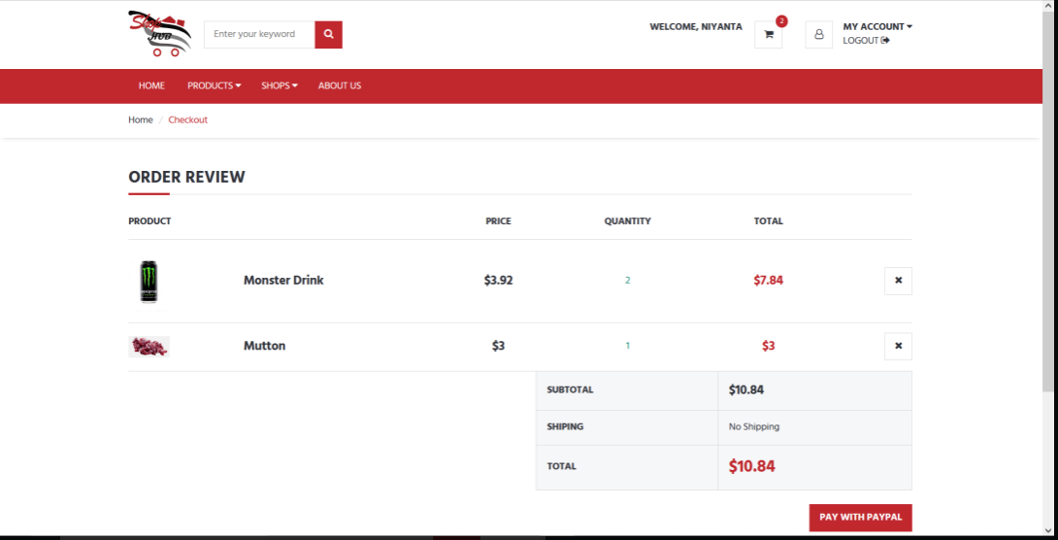

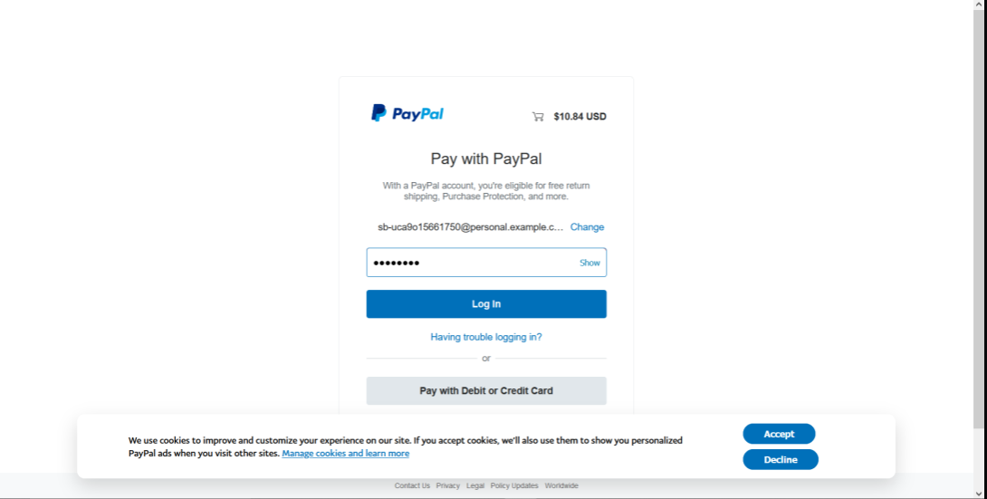

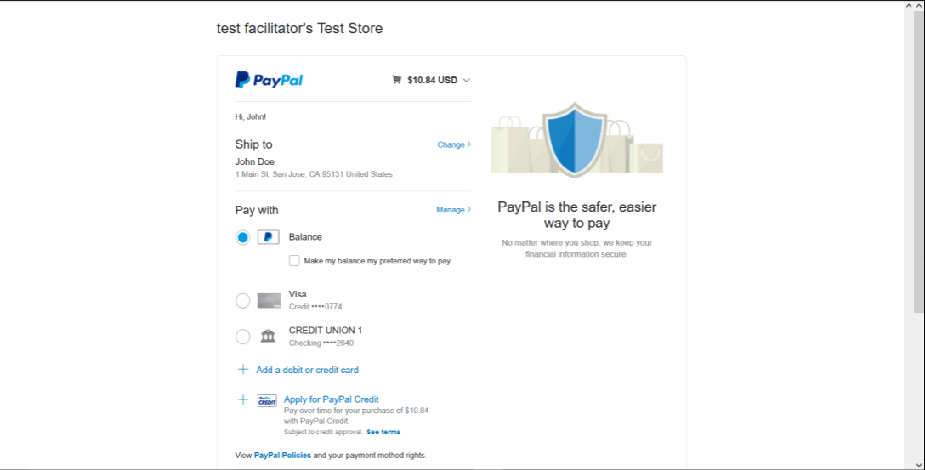

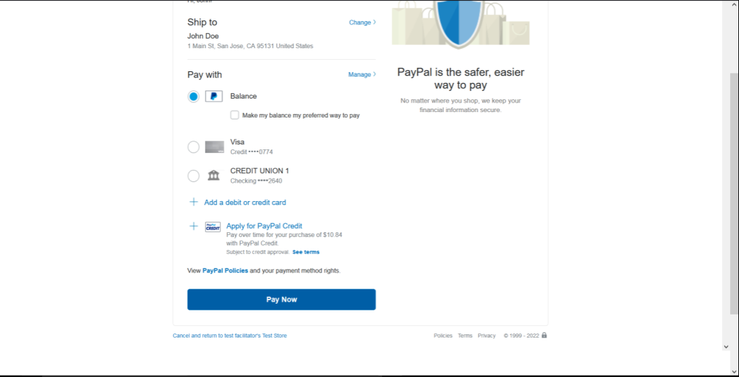

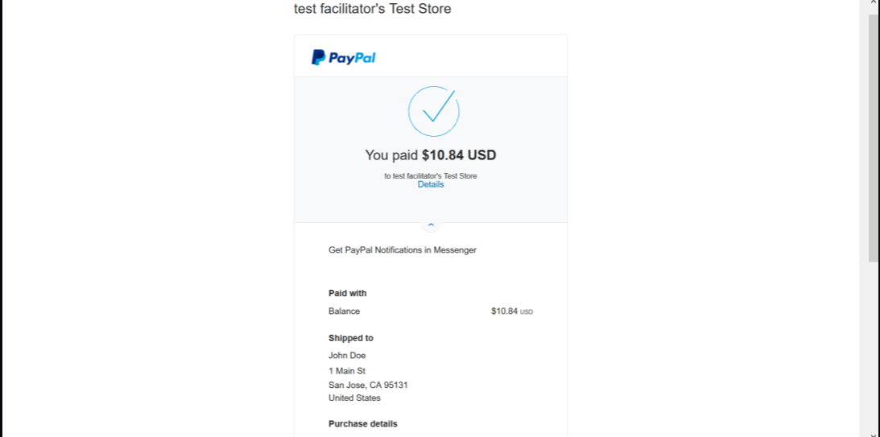

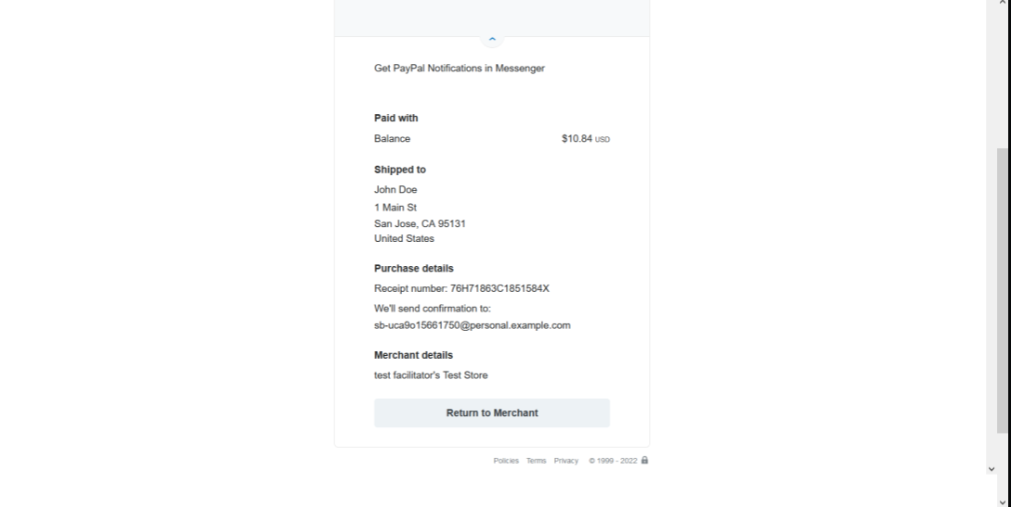

## Scenario 6

**Task:** Give Review Ratings

**Persona:** Niyanta chettri

**User Group:** Registered customer

#### Scenario

Nayanta verified the registered customer and wants to give a review to the products

### Steps:

* Nayanta opens the ShopHub site in her browser
* Nayanta clicks on **Login**
* Nayanta enters her details in the Login form
* Instant validation for any mistakes in the Login form is available
* Nayanta clicks **Submit** button
* Nayanta is now logged in
* Niyanta goes to the product that she wants to give Review and Rating and writes the review.

